**RUN! – User Manual**

1. Overview:

Run! Is an obstacle avoidance game involving the player jumping and ducking over and under multiple obstacles (see part 2). The objective of the game is to continue to avoid objects for as long as possible in order to achieve a high score (see part 3). The player is able to control an on screen character, which will be jumping or ducking on the command of the player. Players must use timing and strategy to clear through as many obstacles as possible. Once the player fails to avoid an obstacle by jumping or ducking the game will end.

2. Jumping/Ducking:

The user controlling the on screen player will jump/duck by clicking the up/down arrow keys on the keyboard. These actions must be done to avoid obstacles and achieve a high score. It is best for users to keep in mind how long the player will stay in the air when the up arrow key (jump) is pressed, since the on screen player must clear over the obstacle you want to jump over. Timing is a key part of jumping and ducking in Run!



UP ARROW



JUMP



DOWN ARROW



DUCK



3. High Score:

The user will receive a high score on screen once they start playing. You can find this high score on the top right hand corner of the screen once the game starts. The high score increases the further you are able to run. The objective is to receive a higher score. Once the game is over your final high score will be shown on screen. If your high score is within the top ten overall high scores then you will be asked to input your name (max 10 characters) into the system so you can identity which high scores are yours later. To check the current high scores to beat click the high scores button on the main menu (see part 4).

4. Main Menu:

Once the program is started you will be greeted by a main menu. There are different options available on the right side of the screen. To play the game click on the “start” button. To check the high scores that are currently in the top ten click on the “high scores” button. To get in game information on how to play click the “how to play” button. Once you are done playing quit the program by clicking the “exit” button.

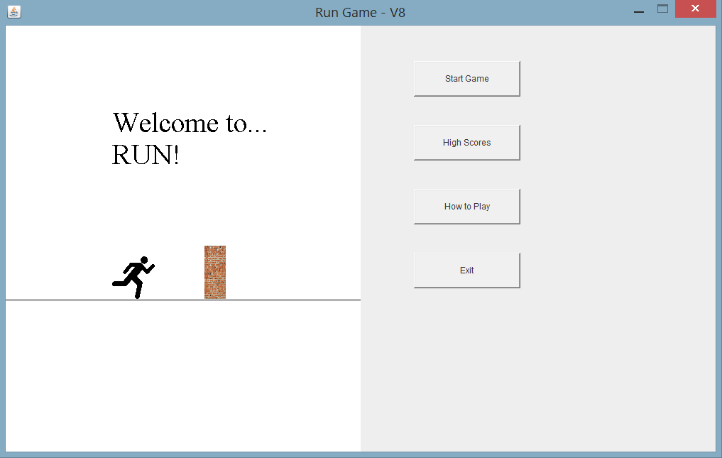

Bonus:

Meet Jeff the hero of our game. Jeff has been in a bit of trouble steeling potatoes from his local farm. The farmers were not happy and are chasing after him. Jeff needs your help to escape the angry farmers or he might get stuffed inside a turkey on thanksgiving! Make sure to avoid those pesky walls Donald Trump has placed around or the farmers will be able to catch up! So good luck and have fun…